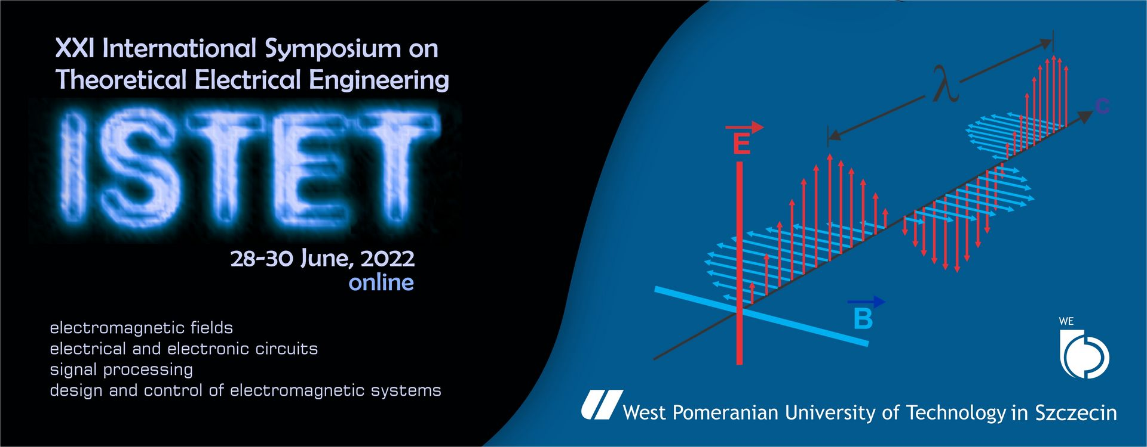
XXI International Symposium
on Theoretical Electrical Engineering
June 28th–30th, 2022 Szczecin, POLAND

E-mail: istet@zut.edu.pl
Web page: www.istet.zut.edu.pl

REGISTRATION FORM
Please use one form per participant. Return by e-mail. All fields are required. Please use capital letters or type following information.

- Participant Information
First Name:
Last Name:
Title: | Prof. | Dr | Mr. | Mrs. | Miss | Ms
Paper title:
Affiliation:
E-mail:

- Data for the invoice
University/company name:
Address:
City: |  | Postcode:
Country:
Phone:
Company’s VAT number:
I agree to making out the VAT invoice without my signature.
I agree to process my personal data for the purpose of ISTET’2022 workshop.

- Registration Fee
Participant category | Until June 15th 2022 |  | After June 15th 2022
Delegate | 150 € |  | 199 €
Student | 100 € |  | 149 €
TOTAL |  |  | €
Please remind that additional paper fee (50 €/paper) will be applied only in case of those participants who paid single registration fee and will have more than 1 final paper accepted for publication post-conference proceedings. In such cases the additional invoice will be sent before publication.
Cancellation policy:
All cancellations must be made in writing to Conference Office (istet@zut.edu.pl)
- up to June 19th, 2022, the registration fee will be fully refunded.
- from June 20th, 2022, the registration fee will not be refunded.

In accordance with the regulation for personal data protection, I hereby agree to process my personal data and publication of my image for documentary and promotional purposes of the Faculty of Electrical Engineering, West Pomeranian University of Technology, Szczecin.

.......................................
(date, signature)
- Method of payment

Bank transfer to the following account:

Bank name: Santander Bank Polska S.A. oddział 3 W SZCZECINIE

Bank address: ul. Piłsudskiego 7, 70-422 Szczecin
SWIFT code: WBKPPLPP
IBAN: PL 02 1090 1492 0000 0000 4903 0242
Beneficiary address: Zachodniopomorski Uniwersytet Technologiczny w Szczecinie, al. Piastów 17,
70-310 Szczecin

In the transfer title field please provide your First Name, Last Name and and the tag “ISTET 2022”

Please ensure that Participant’s name and ISTET 2022 is quoted on payment documents or correspondence !

Please note that the amount that is payable to West Pomeranian University of Technology in Szczecin must be for the full registration fee. Any bank charges that are needed for the transfer must be paid by the participant.

