# John STANLEY*1, Edward SMITH 2, Jane HUTTON 3

University of Colorado (1), West Pomeranian University of Technology (2), Warsaw University of Technology (3)

**Preparation of Short Paper for ISTET 2022**

***Abstract****. These instructions give you guidelines for preparing of short paper for ISTET 2022. The authors are requested to prepare the papers according to the recommendations below. All information and this example file for Word can be found on the conference’s web page: http://www.istet.zut.edu.pl/. The length of the short paper should not be larger than one page. This file is a template, so we recommend pasting your content while maintaining the styles existing in this document.*

**Keywords:** please insert 3 – 4 keywords or phrases.

## Introduction

The short paper must be written in English by using the MS Word editor. The paper should be prepared as a “camera-ready” version using A4 paper format with the following margins: upper, left and right margins set at 1.8 cm and bottom margin set at 2.5 cm. The first line comprises the authors’ names (type size 10 with Arial font). Please mark the corresponding author with the “*” symbol and the presenting author (taking part in the conference) with an underline. Underneath the author’s name, insert the authors’ affiliation (type size 8 with Arial font). Insert two blank lines and then add the title of the paper (type size 16 with Arial bold font). Insert a further two lines and write abstract (type size 7.5 with Arial Italic font) and keywords (type size 8). Insert one line and add the section line. There should be two columns with a separation of 5 mm.

## Formatting of the text

## The length of the short paper should be limited to one page. The whole paper is written using type size 9 and Arial font with the indentation set at 5 mm. Directly after section headings (type size 9 using Arial bold), place the text in justified style. For figure captions, names of the tables, and footnotes, use Arial font with type size 8. When symbols need to be inserted into the text, use the option “*Insert/symbol*” (for example Δα or ϑ∈∞). Please do not use the equation editor in this case. The equation editor should only be used if a symbol does not exist in the symbol list – for example. Although the whole text is written using Arial font, for symbols, please use the Times New Roman italic – for example, *J* and not *J* (i.e. the same symbols as in the equations).

## Equations

Use the MS Word built-in equation editor (*Insert New Equation* on the *Insert* tab) for equations in your paper. Number equations consecutively with equation numbers in parentheses flush with the left margin, as in (1). The typical equation should be as:

(1) $f\left(x\right)=a_{0}+\sum_{n=1}^{∞}{\left(a_{n}\cos{\frac{nπx}{L}}+b_{n}\sin{\frac{nπx}{L}}\right)}$,

where: *x* – variable, *L* – interval, *n* – harmonic number, *a*0*, a*n*, b*n – coefficients.

Insert the equation number on the left side. Between the text and the equation, please leave the distance of 8 points. Refer to “(1),” not “Eq. (1)” or “equation (1)” except at the beginning of a sentence: “Equation (1) is…”.

## Figures

Place figures in the center of columns and preferably at the bottom or on the top of the page.

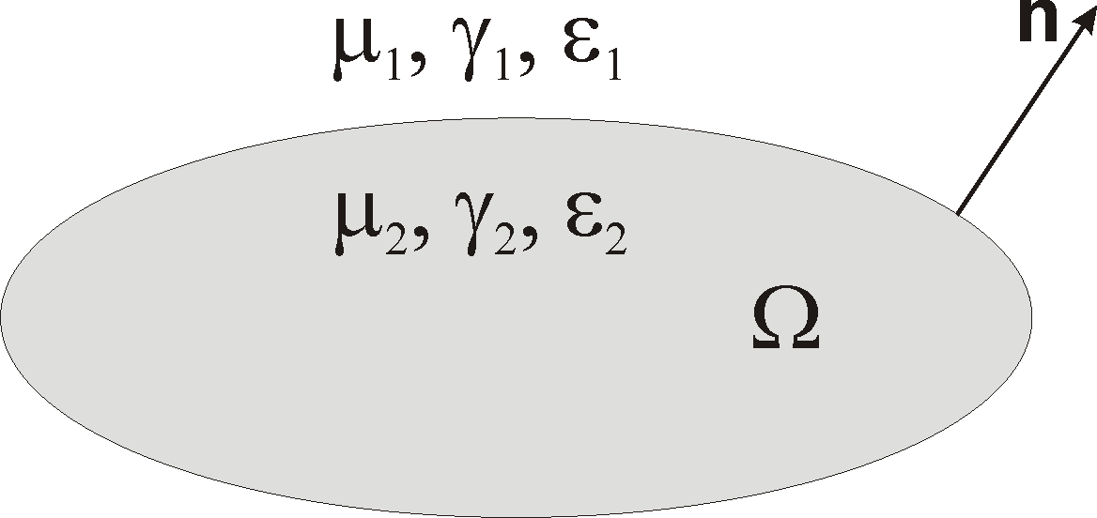

Fig.1. An example of the figure inserted into the text

## Tables

Tables (if necessary) should be included as graphical, not editable content. The tables must be placed in the center of the column. An example of a table is presented below.

## Table 1. The parameters of the sensor



## *Acknowledgments can be inserted at the end of the article using type size 9 and Arial italic: This work was partially supported by the NCN, Poland, under the Grant No. 2021/02/X/ST7/02459.*

## References

References are cited in the text by square brackets [1]. Two or more references at the time may be put in one set of the brackets [2, 3]. The references are numbered in the order in which they are cited. The references are written using type size 8 with Arial font. The style of the references is as follows:

REFERENCES

[1] Johnson B., Pike G.E., Preparation of Papers for Transactions, *IEEE Trans. Magn*., 50 (2002), No. 5, 133-137

[2] Lee P. J., Engineering superconductivity, *Wiley&Sons* 2001

***Authors****: John Stanley, University of Colorado, address, E-mail, Edward Smith, West Pomeranian University of Technology, address, E-mail, Jane Hutton, Warsaw University of Technology, address, E-mail*